APA Blog Citation

Author, F.M. (Year, Month, Date of post). Title of blog post [Blog post]. Retrieved from URL
Note: If a full name is not given, use the author’s screen name or handle instead.
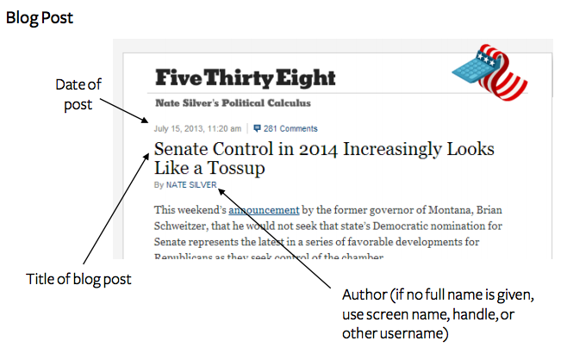
Example:
Silver, N. (2013, July 15). Senate control in 2014 increasingly looks like a tossup [Blog post]. Retrieved from http://fivethirtyeight.blogs.nytimes.com/2013/07/15/senate-control-in-2014-increasingly-looks-like-a-tossup/

