CITING ONLINE IMAGES

- Use the Gale In-Context Databases via the Destiny
Homepage
(for easy, full-service citations)!

The Gale databases in the In Context series (Student Resources in Context, US History in Context, World History in Context and Science in Context) will do the citation work for you. Images are treated independently from articles.

- Search a topic (for example, athlete Jesse Owens);

- Find the On This Page menu of results options;

- Locate and select Images;

- Choose the image you prefer. Notice that there is often a short but helpful
explanation of the image underneath (which Google will never provide!);

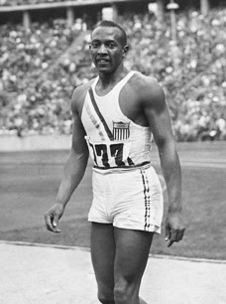

Jesse Owens at the 1936 Olympics in Berlin, which were hosted by Adolf Hitler. Owens won gold medals in the broad jump, 100-meter, 200-meter, and 400-meter relay, breaking Olympic records in all except the 100 (which he tied). Hitler left the stadium rather than present the medals.

- Find the citation in the box near the bottom of the page. It is already in
MLA 8th edition format (or select APA or Chicago style if you prefer), so simply copy and paste the content, up to--and including--the .com. Be sure to put a period at the end of the citation when you finally “land” it in a works cited:

"Jesse Owens at the 1936 Olympics in Berlin, which were hosted by Adolf Hitler. Owens won gold medals..."
African American Almanac, edited by Brigham Narins, 10th ed., Gale, 2008. Gale In Context: High School,
https://link.gale.com.

- Consider using the Google Drive drop feature, which will save the image and the citation for you.

----------------------------------------------------------------------------------------------------

B. Try Power Library (more complicated, but also full-service)!

Find and select Power Library in the Look Here section of the Destiny homepage (This section is right above the Gale databases);

- Pick List all e-resources from the FIND area at the top of the screen;

- Choose the AP Images button;
*You will be prompted to enter an eCard or public library barcode number. If you select the link for “get an eCard now” and complete a short form, your number will be sent to you very quickly via email.

- Complete any of the EBSCOhost search boxes you find relevant. In addition to the main search bar, be sure to select--at least--the Source Type (photo) before you hit the search button;

- Choose your desired photo from the results list. Notice that you can sort your results by relevance or date (see just above and to the right of the results list). As with Gale, you will generally see helpful text in the Description area underneath the photo:

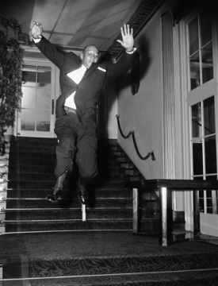

Description:
Olympic broad jump champion Jesse Owens shows his old form for benefit of the photographer at the Waldorf-Astoria Hotel in New York City where he was honored on Oct. 12, 1954, with other athletes at banquet for the all-time U.S. Olympic Games track and field team. In 1936 at Berlin, Germany, Jesse set records in winning the Olympic 100 and 200-meter runs and the broad jump. Banquet opened National Olympic Day drive to obtain public backing for U.S. team participation in the 1955 Pan American and 1956 Olympic games.

- Look to the right of the screen and select the Cite link from the Tools bar
(Also notice that there is a Google Drive drop to save your image and description--not your citation--within the Tools bar);

- Scroll down through the alphabetically-organized citation formats in order to
find the specific citation style you need. Again, stop after the .com if you
choose MLA.

----------------------------------------------------------------------------------------------------

C. Cite It the Hard Way (by hand).

Treat the website containing the image as the overall “container.” You will need to look throughout the container (especially the start and very end of the website) for whatever elements of the following MLA template you can find. You will likely not find all of the elements; skip what you cannot locate. As always with MLA, stop the citation after the .com, .org, .edu, etc.

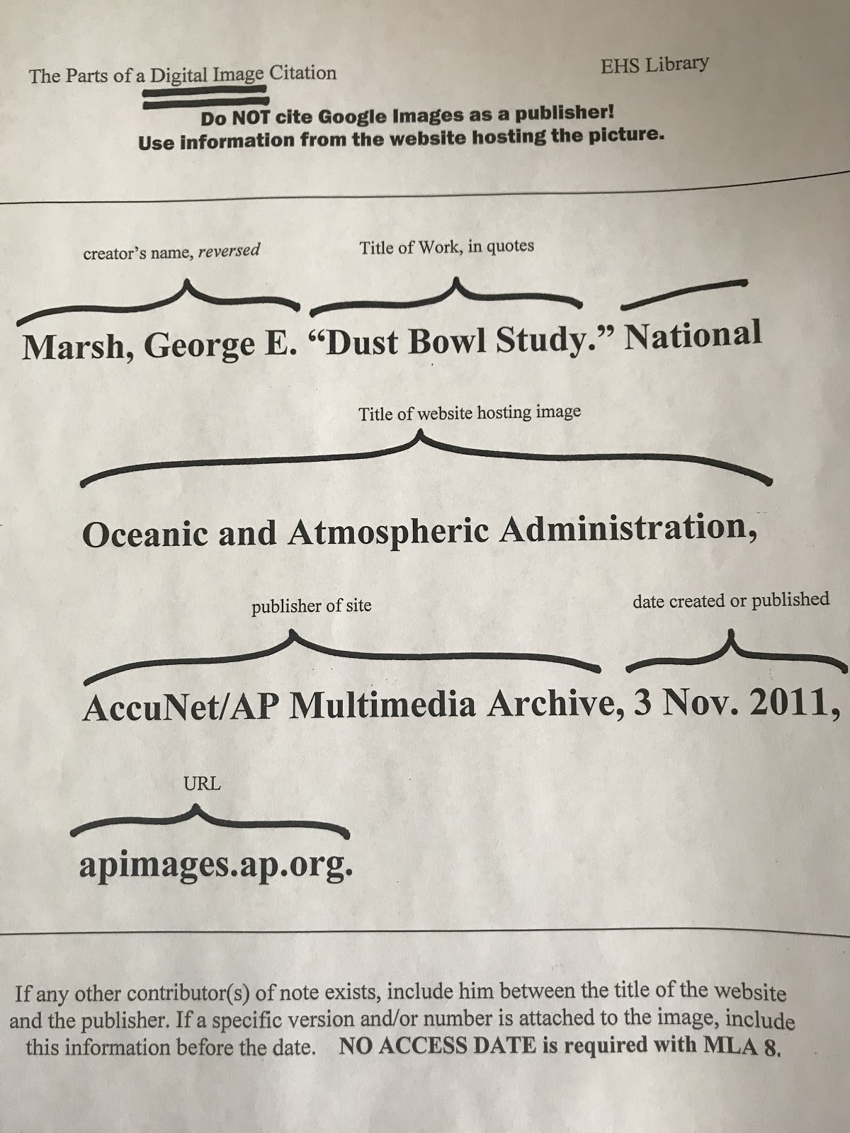
--Created by K.A. Bower, EHS Librarian Feb. 2020

